# CSA1523- CLOUD COMPUTING AND BIG DATA ANALYTICS FOR HEALTHCARE INDUSTRIES

**D.Hemalatha**

**192311107**

**EXP 5. Create a simple cloud software application for the Library book reservation system for the SIMATS library using any Cloud Service Provider to demonstrate SaaS.**

# AIM:

To create a simple cloud software application for a Library book reservation system for SIMATS library using any Cloud Service Provider to demonstrate SaaS.

# PROCEDURE:

STEP 1: Log in to ZOHO Creators and click Create a new application.

STEP 2: Choose from scratch and name the application (Ex-Library book reservation system)

STEP 3: Create a new form as per the requirements. (Ex- User Registration form, Book Listing Form, Book Reservation Form, etc)

STEP 4: Drag and place the required fields and click DONE.

STEP 5: Now open each module and give the required details to store it in the report.

STEP 6: Verify the entries of the User Registration form, Book Listing Form, Book Registration Form, etc from Module Reports.

STEP 7: The software has been created successfully.

# IMPLEMENTATION:

STEP1: Login to ZOHO Creators and click Create a new application.

STEP 2: Choose from scratch and name the application (Ex-Library book reservation system)

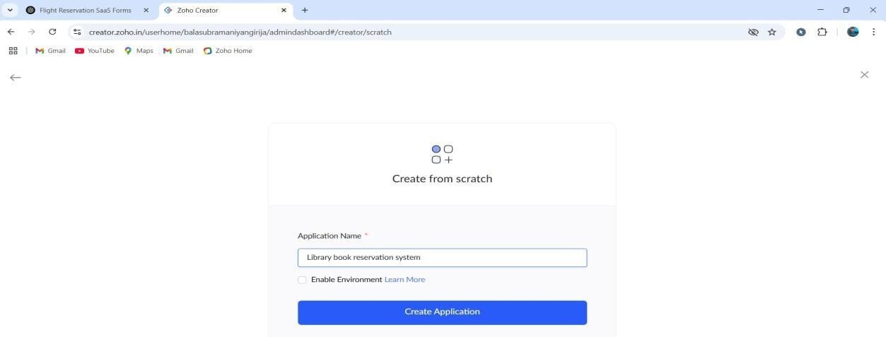

STEP 3: Create a new form as per the requirements. (Ex- User Registration form, Book Listing Form, Book Reservation Form, etc)

User Registration form:

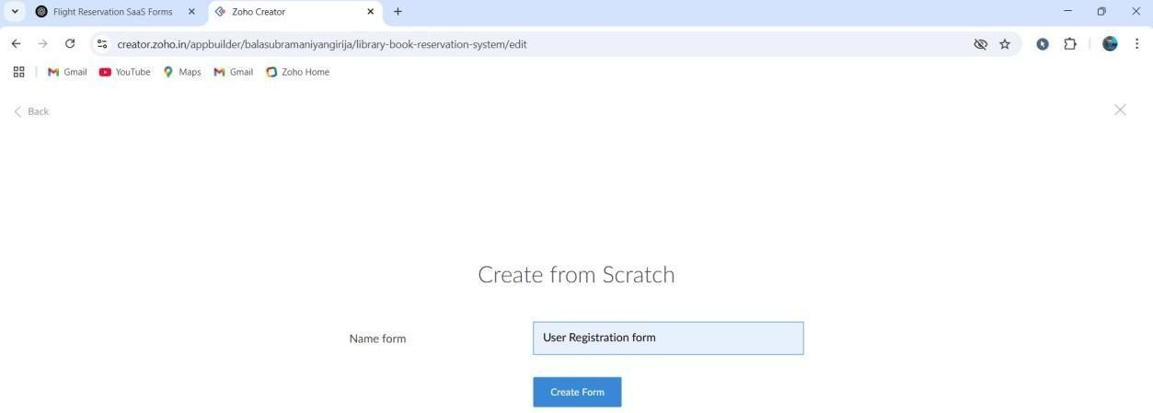

STEP 4: Drag and place the required fields and click DONE.

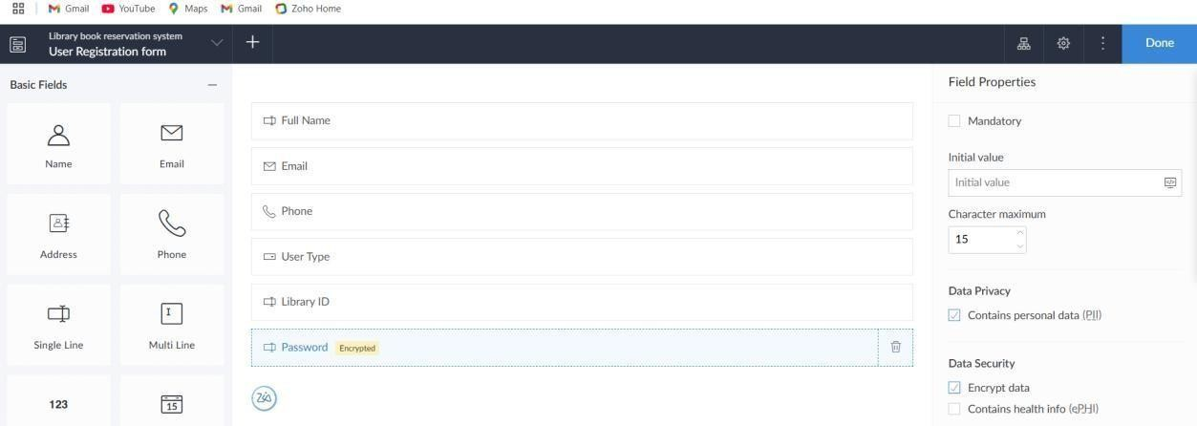

Book Listing Form:

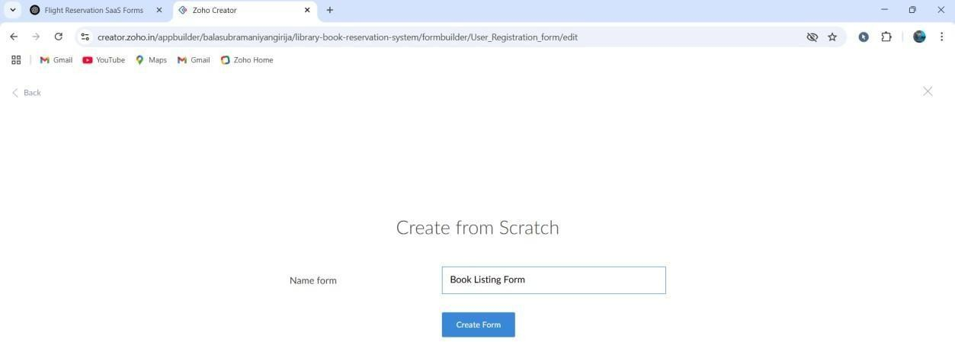

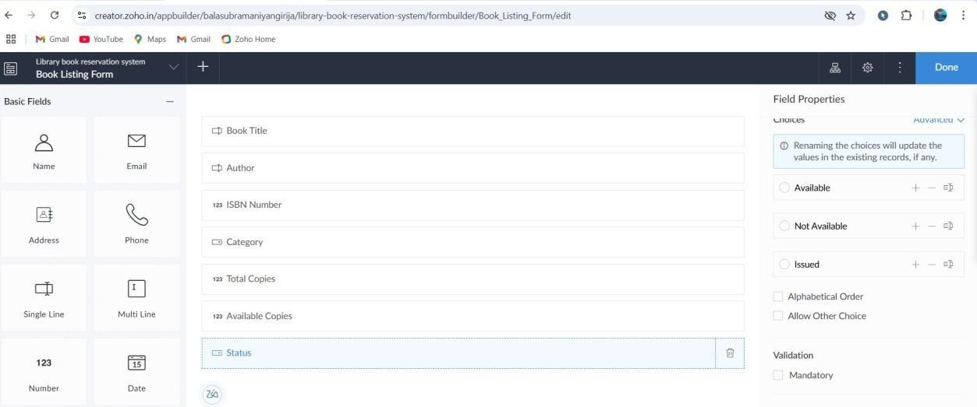

Book Reservation Form:

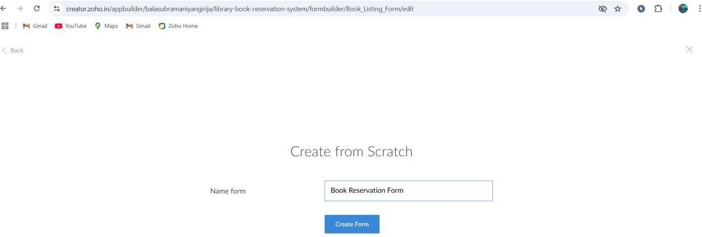

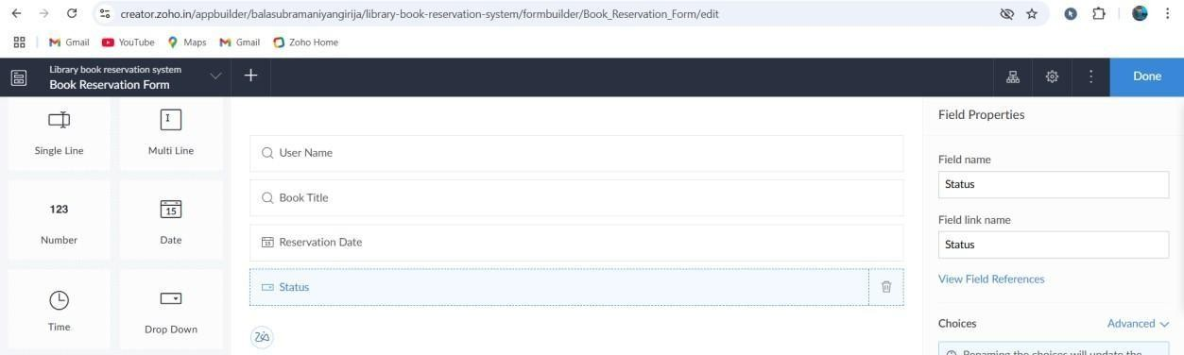

STEP 5: Now open each module and give required details to store it in the report. User Registration form:

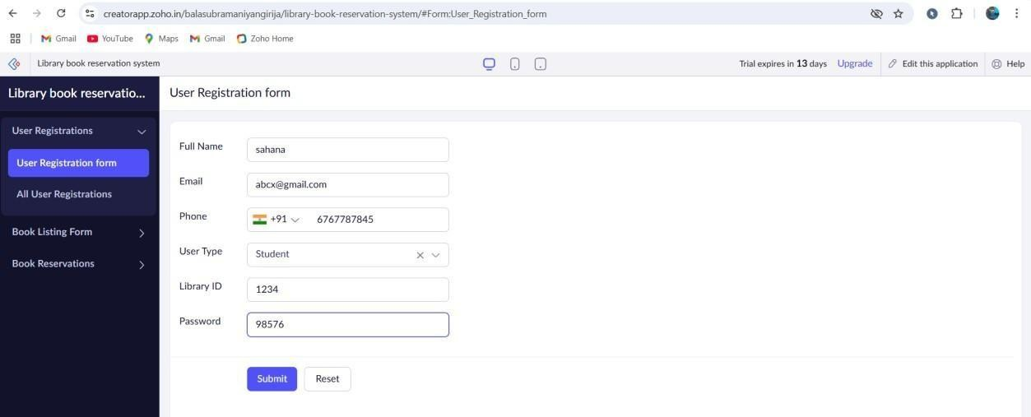

Book Listing Form:

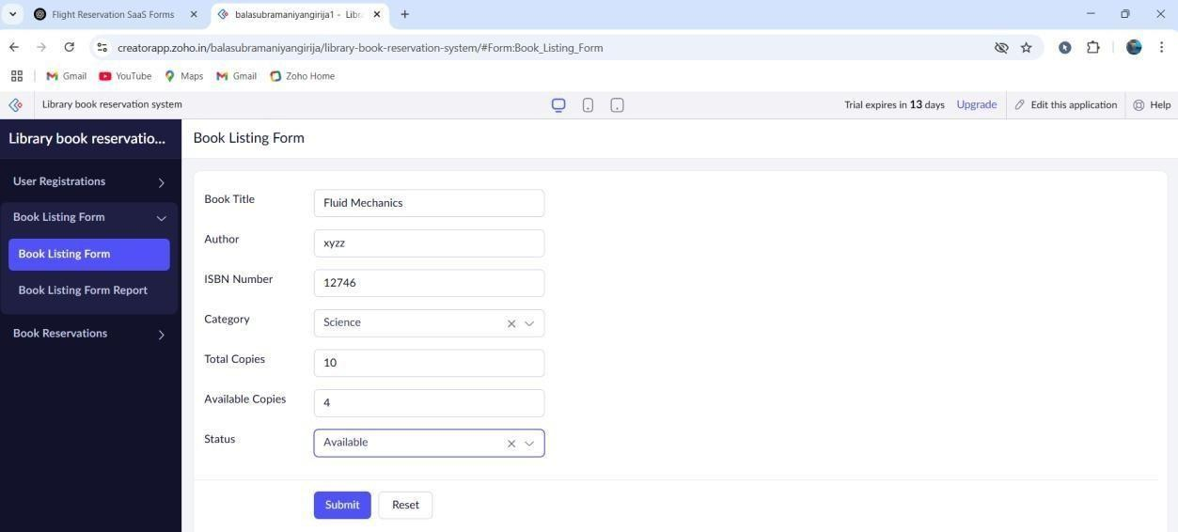

Book Reservation Form:

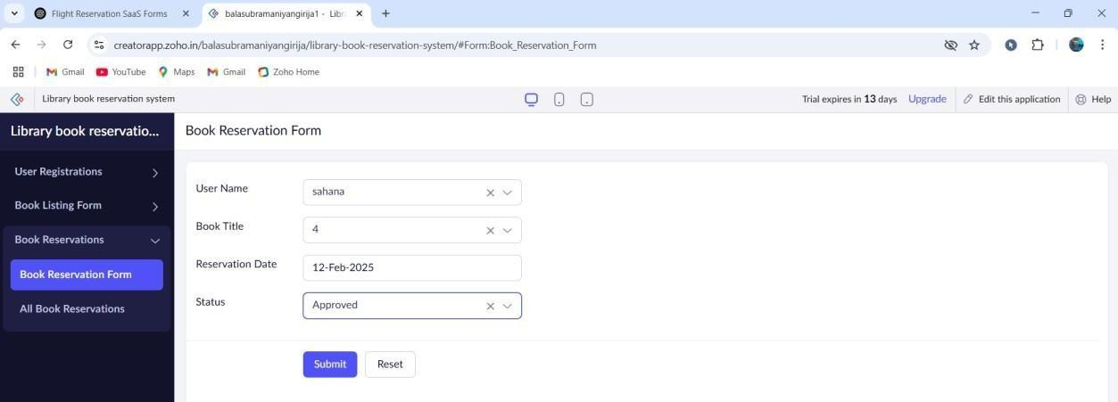

STEP 6: Verify the entries of the User Registration form, Book Listing Form, Book Registration Form, etc from Module Reports.

User Registration form:

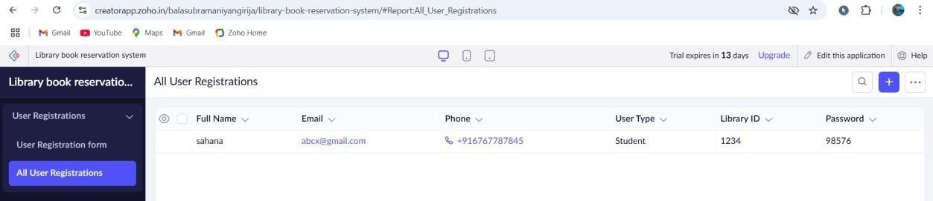

Book Listing Form:

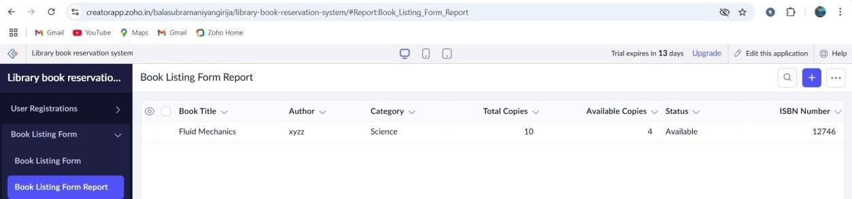

Book Reservation Form:

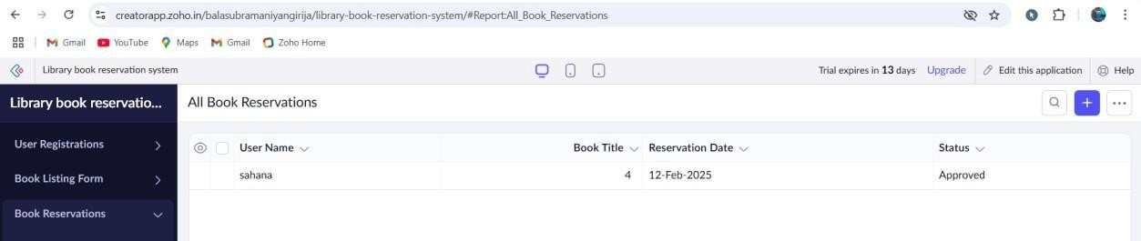

# RESULT:

The software has been created successfully.